**Nepal College of Information Technology**

**Balkumari, Lalitpur**

**Analysis and Design of Algorithm**

1. What is the need for algorithm analysis? How would you perceive the best, worst and average case complexities? Give an example, along with a suitable graph. (8)
2. Explain the master's method for solving the recurrence relations. Solve the following recurrence relations using the master's method. (8)
   1. T(n) = 2T(n/4) + √n
   2. T(n) = 3T(n/2) + n
   3. T(n) = 4T(n/3) + n2
3. Explain Binary search tree. Write an algorithm to delete an element from BST and find its time complexity. (8)
4. Briefly explain a Queue and Priority Queue. Write algorithm to add and remove an element from the circular queue and compute the complexity of your algorithm. (8)
5. Write an algorithm for quick-sort and trace out the algorithm for the given array A [] = {-4, 1, 25, 50, 8, 10, 23}. (8)
6. What is the difference between fractional knapsack and 0/1 knapsack. Consider the following 7 items and the knapsack has capacity of 15. Find an optimal solution using fractional knapsack. (8)

| **Object(O)** | **1** | **2** | **3** | **4** | **5** | **6** | **7** |
| --- | --- | --- | --- | --- | --- | --- | --- |
| Profits(P) | 10 | 5 | 15 | 7 | 6 | 18 | 3 |
| Weights(w) | 2 | 3 | 5 | 7 | 1 | 4 | 1 |

1. Consider the set of given jobs as shown. Find a sequence of jobs, which will give maximum profit. (8)

| **Jobs** | **J1** | **J2** | **J3** | **J4** | **J5** | **J6** |
| --- | --- | --- | --- | --- | --- | --- |
| Deadlines | 5 | 3 | 3 | 2 | 4 | 2 |
| Profits | 200 | 180 | 190 | 300 | 120 | 100 |

1. Find the edit distance in converting ROS to HORSE. (8)
2. What is the real-life application of tree vertex splitting problem? For δ = 5, add a booster to the following tree. (8)

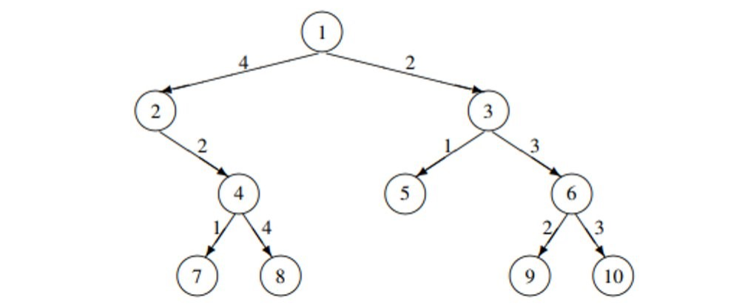

1. What is the optimal binary search tree? Using dynamic approach, build optimal binary tree for the given values. (8)

| Keys | 10 | 20 | 30 | 40 |
| --- | --- | --- | --- | --- |
| Frequency | 4 | 2 | 6 | 3 |

1. What is the backtracking method for problem solving? Explain how you solve the 8-queen problem using the backtracking method. (8)
2. Write short notes on (Any two) (2*6)
   1. Multistage Graph
   2. Strassen’s Matrix Multiplication
   3. Optimal Binary Tree.